**PROBLEM#01**

**Q** :Write a program which prints measurement of temperature according to user input values.

**SOURCE CODE:**

**#include <stdio.h>**

**int main(void){**

**// variable for temperature**

**int temp;**

**//heading**

**printf("\n \t********\t MEASURMENT OF TEMPETAURE \t********\t");**

**printf("\n\n ENTER TEMPERATURE IN DEGREES \n");**

**scanf("\n %d",&temp);//take input temperature in integer**

**if(temp >= 50){**

**printf("\n TEMPERATURE IS VERY HOT \n");**

**}**

**else if(temp >= 40 && temp < 50){**

**printf("\n TEMPERATURE IS HOT \n");**

**}**

**else if(temp >= 30 && temp < 40){**

**printf("\n TEMPERATURE IS MILD \n");**

**}**

**else if(temp >= 20 && temp < 30){**

**printf("\n TEMPERATURE IS PLEASENT \n");**

**}**

**else if(temp >= 10 && temp < 20){**

**printf("\n TEMPERATURE IS COLD \n");**

**}**

**else if(temp >= 0 && temp < 10){**

**printf("\n TEMPERATURE IS VERY COLD \n");**

**}**

**else if (temp < 0){**

**printf("\n TEMPERATURE IS FREEZING \n");**

**}**

**//end of code**

**getche();**

**}**

**OUTPUT:**

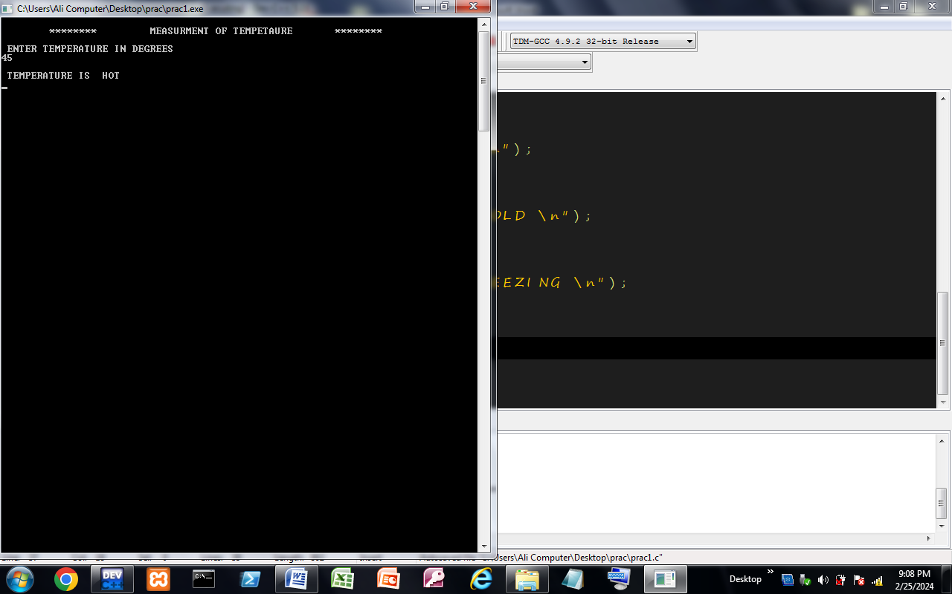

Made By :

***Kashan Ali Khan(BS-SE)***